CHECKPOINT

EJERCICIO 1

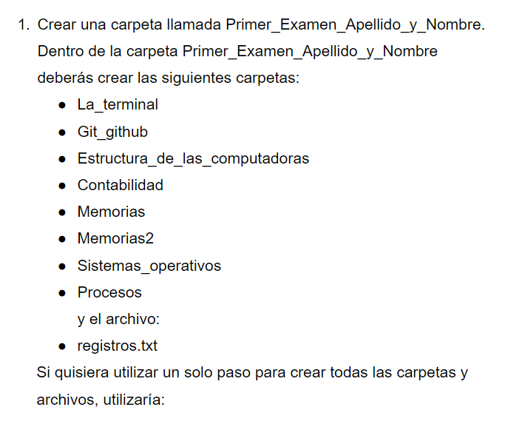

usuario@DESKTOP-KPODLUD MINGW64 ~/OneDrive/Escritorio (main)

$ git clone https://github.com/JoaquinMarmol/Checkpoint1-intro.git

Cloning into 'Checkpoint1-intro'...

warning: You appear to have cloned an empty repository.

usuario@DESKTOP-KPODLUD MINGW64 ~/OneDrive/Escritorio (main)

$ cd Checkpoint1-intro/

usuario@DESKTOP-KPODLUD MINGW64 ~/OneDrive/Escritorio/Checkpoint1-intro (main)

$ mkdir Primer_Examen_Marmol_Joaquin

usuario@DESKTOP-KPODLUD MINGW64 ~/OneDrive/Escritorio/Checkpoint1-intro (main)

$ cd Primer_Examen_Marmol_Joaquin/

usuario@DESKTOP-KPODLUD MINGW64 ~/OneDrive/Escritorio/Checkpoint1-intro/Primer_Examen_Marmol_Joaquin (main)

$ mkdir La_terminal Git_github Estructura_de_las_computadoras Contabilidad Memorias Memorias2 Sistemas_Operativos Procesos

usuario@DESKTOP-KPODLUD MINGW64 ~/OneDrive/Escritorio/Checkpoint1-intro/Primer_Examen_Marmol_Joaquin (main)

$ touch registros.txt

EJERCICIO 2

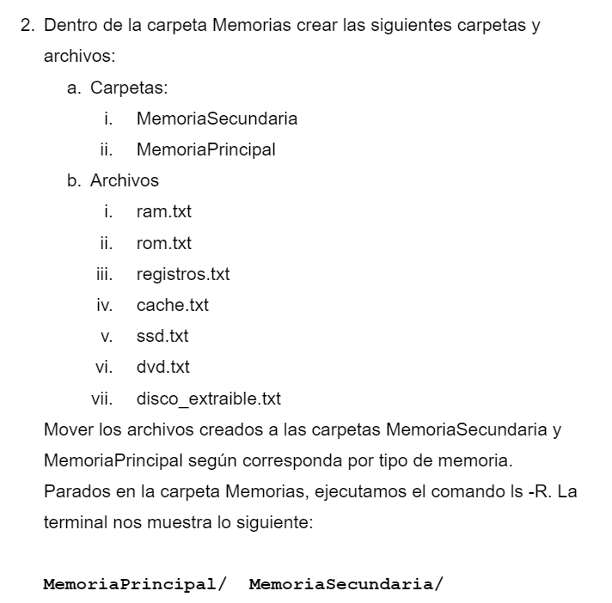

usuario@DESKTOP-KPODLUD MINGW64 ~/OneDrive/Escritorio/Checkpoint1-intro/Primexamen_Marmol_Joaquin (main)

$ cd Memorias

usuario@DESKTOP-KPODLUD MINGW64 ~/OneDrive/Escritorio/Checkpoint1-intro/Primexamen_Marmol_Joaquin/Memorias (main)

$ mkdir MemoriaSecundaria MemoriaPrincipal

usuario@DESKTOP-KPODLUD MINGW64 ~/OneDrive/Escritorio/Checkpoint1-intro/Primexamen_Marmol_Joaquin/Memorias (main)

$ touch ram.txt rom.txt registros.txt cache.txt ssd.txt dvd.txt disco_extraibtxt

usuario@DESKTOP-KPODLUD MINGW64 ~/OneDrive/Escritorio/Checkpoint1-intro/Primexamen_Marmol_Joaquin/Memorias (main)

$ mv ram.txt rom.txt registros.txt cache.txt MemoriaPrincipal/

usuario@DESKTOP-KPODLUD MINGW64 ~/OneDrive/Escritorio/Checkpoint1-intro/Primer_Examen_Marmol_Joaquin/Memorias (main)

$ mv ssd.txt dvd.txt disco_extraible.txt MemoriaSecundaria/

usuario@DESKTOP-KPODLUD MINGW64 ~/OneDrive/Escritorio/Checkpoint1-intro/Primer_Examen_Marmol_Joaquin/Memorias (main)

$ ls -R

.:

MemoriaPrincipal/ MemoriaSecundaria/

./MemoriaPrincipal:

cache.txt ram.txt registros.txt rom.txt

./MemoriaSecundaria:

disco_extraible.txt dvd.txt ssd.txt

EJERCICIO 3

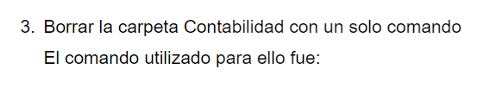

usuario@DESKTOP-KPODLUD MINGW64 ~/OneDrive/Escritorio/Checkpoint1-intro/Primer_Examen_Marmol_Joaquin/Memorias (main)

$ cd ..

usuario@DESKTOP-KPODLUD MINGW64 ~/OneDrive/Escritorio/Checkpoint1-intro/Primer_Examen_Marmol_Joaquin (main)

$ rmdir Contabilidad/

EJERCICIO 4

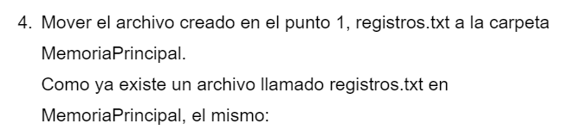

usuario@DESKTOP-KPODLUD MINGW64 ~/OneDrive/Escritorio/Checkpoint1-intro/Primer_Examen_Marmol_Joaquin (main)

$ mv registros.txt Memorias/MemoriaPrincipal/

EJERCICIO 5

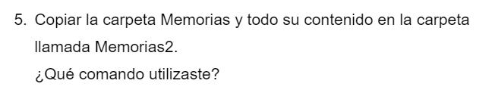

usuario@DESKTOP-KPODLUD MINGW64 ~/OneDrive/Escritorio/Checkpoint1-intro/Primer_Examen_Marmol_Joaquin (main)

$ cp -r Memorias Memorias2